
AI CAREER FOR WOMEN
Engineering

DISHA AI
AI-Based Disaster Prediction, Detection and Response System

A Project Report
submitted in partial fulfillment of the requirements
of
AICW project.

by
K BHARGAVI kothurubhargavi146@gmail.com
G LOHITHA gadelohithareddy@gmail.com
M Lami Prasanna marthiprasanna846@gmail.com
J AKHILA juujriakhila@gmail.com

Under the Guidance of
Dr.Rahul Nawkhare

ACKNOWLEDGEMENT
We would like to take this opportunity to express our sincere and heartfelt gratitude to all those who have supported, guided, and encouraged us, either directly or indirectly, throughout the successful completion of this project. First and foremost, we express our deepest gratitude to our esteemed Project Supervisor, Dr. Rahul Nawkhare, for his invaluable guidance, continuous encouragement, constructive suggestions, and constant support throughout the course of this project. His valuable advice, critical observations, and motivation have been a constant source of inspiration and have played a significant role in the successful completion of our work. His confidence in our abilities encouraged us to overcome challenges and continuously improve our work. It has been a privilege to work under his guidance, and we are truly grateful for the knowledge, professional values, and experience we have gained through his mentorship. We would also like to express our sincere gratitude to our SPOC, Dr. N. Savitha, for her continuous support, valuable guidance, coordination, and encouragement throughout the project. We extend our heartfelt thanks to our respected Chairman, Dr. R. J. C. G Krishna, for providing us with the necessary support, facilities, and encouragement to pursue our academic and project work successfully. We are also deeply grateful to our esteemed Secretary and Correspondent, G. Dhatri, for his constant encouragement and for providing an environment that promotes learning, innovation, and academic excellence. We sincerely thank our respected Principal, Dr. G. Raj Kumar, for his valuable support, encouragement, and for providing us with the academic environment and facilities necessary for the successful completion of this project. We would also like to express our sincere appreciation to all the faculty members and teachers of our institution for their valuable guidance, suggestions, encouragement, and support throughout our academic journey. Their knowledge, teaching, and continuous motivation have greatly contributed to our learning and professional development. Finally, we express our heartfelt gratitude to our parents, friends, classmates, and everyone who supported us during the course of this project. Their encouragement, patience, and support gave us the confidence and motivation to complete this work successfully. We are truly grateful to everyone who contributed to this project in any way and helped us make its successful completion possible.
K BHARGAVI
G LOHITHA
M LAXMI PRASANNA
J AKHIL

ABSTRACT OF THE PROJECT
Disha AI – AI-Based Disaster Prediction, Detection and Response System is an intelligent and integrated disaster management solution designed to support timely prediction, accurate detection, and effective response to natural and man-made disasters. The system leverages Artificial Intelligence (AI), Machine Learning (ML), Deep Learning, Computer Vision, Natural Language Processing (NLP), Retrieval-Augmented Generation (RAG), and Agentic AI to analyze diverse sources of information, including historical disaster records, real-time weather data, sensor and IoT data, satellite information, images, videos, and user-generated reports. Machine Learning and Deep Learning techniques are utilized to identify patterns and estimate potential disaster risks, while Computer Vision enables the analysis of visual data for detecting disaster-related situations. NLP, RAG, and an AI-powered chatbot provide users with relevant information, safety guidelines, emergency instructions, and context-aware assistance during critical situations. The system aims to provide early warnings, disaster-specific information, preparedness recommendations, and response guidance to help individuals and authorities make informed decisions. By integrating prediction, detection, information retrieval, and intelligent response capabilities into a unified platform, Disha AI seeks to improve disaster preparedness, reduce response time, enhance situational awareness, and support effective decision-making before, during, and after disasters. The proposed system demonstrates the potential of modern AI technologies in developing a smarter, more responsive, and technology-driven approach to disaster management and emergency response. The system is designed with a modular architecture that enables the integration of multiple disaster-related services and data sources. It supports disaster-specific modules that provide relevant information, safety protocols, preventive measures, and emergency response procedures. Real-time data processing helps the system identify changing environmental conditions and potential risks at an early stage. The platform can also utilize visual inputs to strengthen disaster detection and situational assessment. An intelligent chatbot enables users to interact with the system and obtain disaster-related information through natural language queries. RAG technology helps the chatbot provide responses based on relevant and reliable knowledge sources. Agentic AI can assist in coordinating multiple tasks and providing appropriate guidance according to the situation. The system is intended to improve communication between users, technology-driven services, and emergency response mechanisms. Its integrated approach can help minimize information delays and support better preparedness during emergency situations. Overall, Disha AI provides a technology-driven framework for building a safer, smarter, and more resilient disaster management ecosystem.

TABLE OF CONTENTS
Abstract
List of Figures
List of Tables

Chapter 1. Introduction
1.1 Problem Statement
1.2 Motivation
1.3 Objectives
1.4. Scope of the Project
Chapter 2. Literature Survey
Chapter 3. Proposed Methodology
Chapter 4. Implementation and Results
Chapter 5. Discussion and Conclusion
References

LIST OF FIGURES

Figure No. | Figure Title | Page No.
Figure 1.1.1 | Blinkit Sales Analysis Dashboard | 8
Figure 1.1.4 | Total Sales by Fat Content | 10
Figure 3.2.1 | Blinkit on-site development | 18
Figure 3.3.2 | Face registration and Face recognition | 21
Figure 3.6 | Proposed System Workflow | 27
Figure 4.4.2 | Result of Concentration Analysis | 30
Figure 5.1.1 | Model Accuracies Achieved | 33
Figure 5.4.4 | Key Challenges of Using Facial Recognition | 35
Figure 5.5.5 | Future work | 36

LIST OF TABLES

Table No. | Table Title | Page No.
Table 2.1 | Review of Existing Approaches | 12
Table 2.3 | Research Gap Analysis | 15
Table 3.5.1 | Hardware Requirements | 25
Table 3.5.2 | Software Requirements | 26

CHAPTER 1
Introduction

1.1 Problem Statement

Natural and man-made disasters such as floods, earthquakes, cyclones, landslides, wildfires, and other emergencies can cause severe loss of life, property, infrastructure, and natural resources. One of the major challenges in disaster management is the lack of timely, accurate, and easily accessible information before and during an emergency. Existing disaster management approaches often depend on multiple independent sources for weather information, alerts, visual assessment, emergency guidelines, and response coordination, which can result in information delays, fragmented communication, and difficulty in making quick and informed decisions. Furthermore, the large volume of data generated through weather services, sensors, satellite observations, images, videos, historical records, and user reports is difficult to analyse manually in real time.

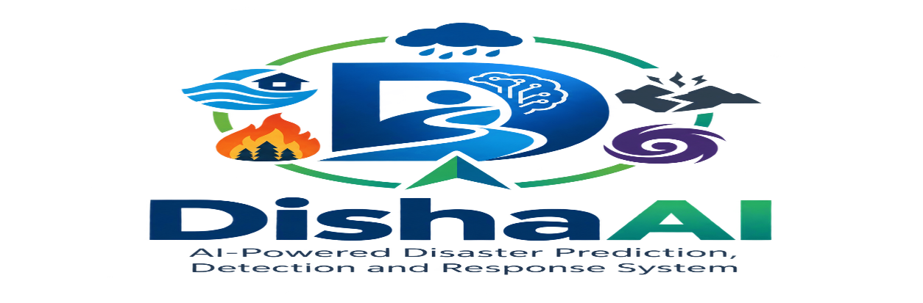
There is therefore a need for an intelligent and integrated system that can analyse diverse data sources, identify potential disaster risks, detect disaster-related conditions, provide timely alerts, and deliver appropriate safety and response guidance. The proposed Disha AI system addresses this problem by integrating Artificial Intelligence, Machine Learning, Deep Learning, Computer Vision, Natural Language Processing, Retrieval-Augmented Generation, and Agentic AI into a unified platform. The system is intended to support disaster prediction, detection, preparedness, information retrieval, and emergency response, thereby improving situational awareness and enabling users and authorities to access relevant information and guidance throughout the different stages of disaster management.

Fig 1.1 DishaAI – Intelligent Disaster Management.

Fig 1.1 illustrates the This logo visually represents DishaAI, an AI-powered disaster prediction, detection, and response system. The design features a stylized letter “D” containing a human figure and a brain icon, symbolizing artificial intelligence and human-centric innovation
1.2 Motivation
The increasing frequency and impact of natural and man-made disasters highlight the need for intelligent, timely, and technology-driven disaster management solutions. During emergencies, the availability of accurate information at the right time can play an important role in reducing risks and supporting effective decision-making. Traditional disaster management approaches may involve multiple sources of information, manual monitoring, and delayed communication, making it difficult to obtain a complete understanding of a developing situation. The rapid growth of Artificial Intelligence, Machine Learning, Deep Learning, Computer Vision, Natural Language Processing, IoT, and real-time data technologies provides an opportunity to address these challenges more effectively. This motivated us to develop Disha AI – AI-Based Disaster Prediction, Detection and Response System, an integrated platform that can analyze diverse sources of information, identify potential risks, detect disaster-related situations, and provide relevant safety and emergency guidance. The inclusion of RAG and Agentic AI further motivates the development of an intelligent assistance system capable of retrieving relevant knowledge and supporting users with context-based disaster information. The primary motivation behind Disha AI is to contribute to a smarter and more responsive disaster management ecosystem that can improve preparedness, enhance situational awareness, support faster access to critical information, and assist individuals and authorities before, during, and after disasters.

1.3 Objectives
The primary objective of Disha AI – AI-Based Disaster Prediction, Detection and Response System is to develop an intelligent and integrated platform that uses modern AI technologies to support disaster prediction, early detection, preparedness, and emergency response. The system aims to analyze data from multiple sources, identify potential disaster risks, provide timely and relevant information, and assist users and authorities in making informed decisions before, during, and after disasters.
- To predict potential disasters and assess associated risks using Machine Learning and Deep Learning techniques.
- To detect disaster-related situations from images and videos using Computer Vision.
- To integrate real-time weather, sensor, satellite, historical, and user-generated data for improved situational awareness.
- To provide early alerts, safety precautions, and disaster-specific emergency guidelines.
- To use NLP and AI-powered chatbot technology for natural and interactive user assistance.
- To implement RAG for retrieving relevant and reliable disaster-related information.
- To utilize Agentic AI for intelligent task handling and context-based response assistance.
- To support effective preparedness, response, and post-disaster assistance through a unified platform.
- To reduce delays in accessing critical information during emergency situations.
- To improve overall disaster awareness, preparedness, and response efficiency through AI-driven technologies.

1.4 Scope of the Project
The scope of DISHA AI – AI-Based Disaster Prediction, Detection and Response System defines the boundaries, applications, and limitations of the proposed work. It ensures clarity on what the system covers and how it contributes to disaster management.
Inclusions
- Disaster Types Covered: Floods, earthquakes, cyclones, and wildfires.
- Technologies Used: IoT sensors, satellite data, AI/ML models, NLP, Computer Vision, and Agentic AI.
- Functional Modules:
  - Prediction: Forecasting disasters using historical and real-time data.
  - Detection: Identifying disaster events through IoT sensors and image/video analysis.
  - Response: Coordinating evacuation, alerts, and resource allocation via dashboards.
- Data Sources: Sensor networks, meteorological data, satellite imagery, and social media feeds.
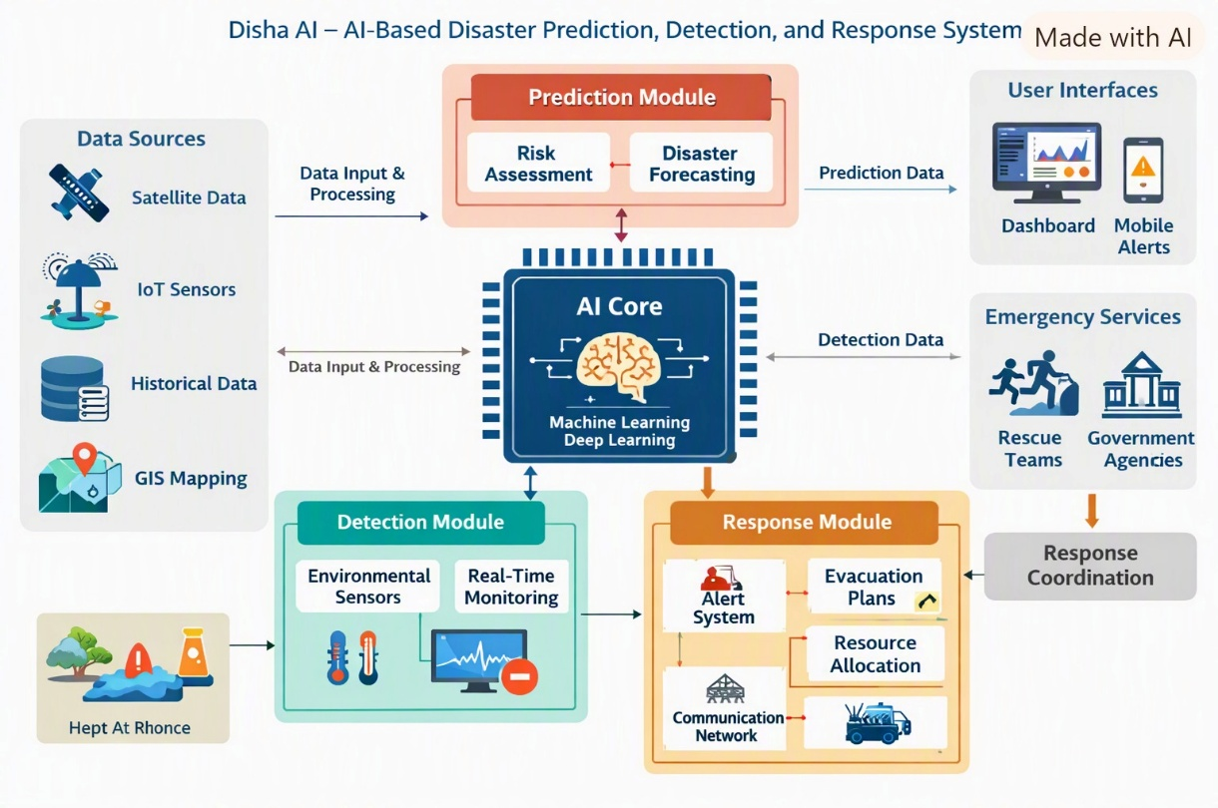
- Outputs: Real-time alerts, evacuation maps, performance metrics, and decision-support dashboards.

Fig 1.2 System Architecture of DishaAI
Fig 1.2 This diagram illustrates how DishaAI integrates diverse data sources (satellite, IoT, GIS, historical records) with AI modules for prediction, detection, and response. It highlights the flow from data input through machine learning processing to dashboards, alerts, and coordination with emergency services.
Limitations
Although the project provides an effective approach to the selected problem, certain limitations may exist. The accuracy of the results depends on the quality, completeness, and reliability of the available data. The project may also be limited by the size and characteristics of the dataset used for analysis. In addition, the solution may focus only on the selected problem domain and may not directly address requirements outside the defined scope.
Future versions of the project can be enhanced by incorporating larger datasets, real-time data processing, advanced analytical techniques, automation, predictive analysis, and additional features according to user requirements.

CHAPTER 2
Literature Survey
  - Review relevant literature or previous work in this domain.

Disaster management has evolved significantly over the past decades, with researchers and practitioners exploring diverse technologies to improve prediction, detection, and response. Early systems relied heavily on manual reporting, radio alerts, and paper maps, which provided basic situational awareness but lacked speed and accuracy. With the advent of the IoT and sensor networks (2000–2010), real-time data collection became possible, enabling early warning systems such as Japan’s seismic sensor network for earthquake alerts. The integration of machine learning and deep learning (2010–2020) further enhanced disaster forecasting, with studies demonstrating the use of neural networks for flood prediction, satellite imagery analysis for cyclone path tracking, and computer vision for fire detection. Recent work emphasizes the role of Agentic AI and Generative AI (2020–present), where autonomous systems can make decisions, coordinate responses, and adapt strategies using Retrieval-Augmented Generation (RAG) and knowledge graphs. Despite these advances, literature highlights persistent gaps in scalability, multilingual communication, and adaptive response mechanisms, underscoring the need for integrated frameworks like DishaAI that combine prediction, detection, and response in a unified system.
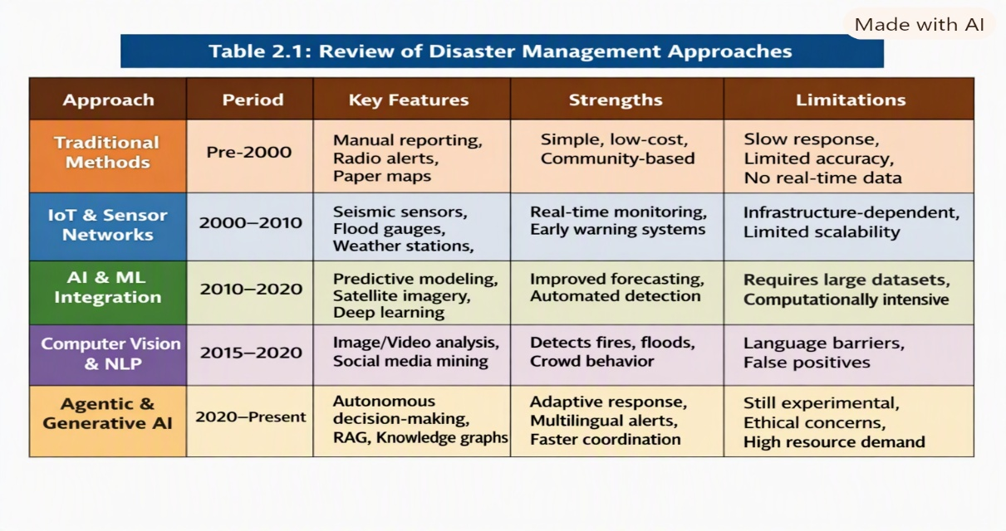
Table 2.1: Review of Existing Approaches

Table 2.1 presents a comparative review of major disaster management approaches developed over time. It outlines how technologies evolved from traditional manual methods to IoT-based sensor networks, AI and machine learning models, computer vision and NLP systems, and finally Agentic and Generative AI frameworks.

  - Existing Models, Techniques and Methodologies
- Over the years, numerous models and methodologies have been developed to enhance disaster prediction, detection, and response. Early frameworks primarily focused on statistical and rule-based models, which relied on historical data and predefined thresholds to forecast events such as floods or cyclones. While these methods provided basic insights, they lacked adaptability to dynamic environmental conditions.
- With the emergence of IoT-based systems, sensor networks began collecting real-time data on temperature, humidity, seismic activity, and rainfall. These systems enabled continuous monitoring and early warning capabilities.
- However, their effectiveness was limited by infrastructure machine learning (ML) and deep learning (DL) revolutionized disaster management. Models such as Random Forests, Support Vector Machines (SVMs), Convolutional Neural Networks (CNNs), and Long Short-Term Memory (LSTM) networks have been applied to predict constraints and data noise.
- The integration of floods, detect fires, and classify satellite imagery. ML algorithms learn from large datasets to identify patterns and anomalies, improving prediction accuracy and detection speed.
- In parallel, Natural Language Processing (NLP) techniques have been used to analyze social media posts and news feeds for real-time situational awareness. Platforms like Twitter and Facebook provide valuable crowd-sourced data that help identify disaster locations and public sentiment.
- Recent advancements in Agentic and Generative AI have introduced autonomous decision-making capabilities. These systems use Retrieval-Augmented Generation (RAG) and knowledge graphs to synthesize information from multiple sources, enabling adaptive response coordination and multilingual communication.

  - Highlight the gaps or limitations in existing solutions and how your project will address them.
Existing disaster management solutions remain fragmented, with most focusing only on prediction or detection without integrating response mechanisms. Many models depend heavily on large, clean datasets, limiting their real-time applicability during emergencies. IoT systems face scalability challenges in rural or resource-constrained areas, while NLP tools struggle with multilingual communication. Current dashboards often lack adaptive intelligence, leading to delayed evacuation and resource allocation. DishaAI addresses these gaps by offering a unified, scalable framework that combines prediction, detection, and response with hybrid data sources, multilingual alerts, and Agentic AI for faster, smarter

Gap 1: Limited Integrated Analysis
- Most existing disaster management systems focus on either prediction, detection, or response, but rarely combine all three into a unified framework. This fragmentation reduces overall efficiency and coordination.
Gap 2: Limited Dataset-Based Visualization
- Current models depend heavily on large, clean datasets and lack dynamic visualization tools This limits real-time decision-making and makes systems less adaptable during emergencies.
Gap 3: Speed Versus Reliability
- While some solutions provide rapid alerts, they often compromise accuracy, leading to false positives or delayed responses. Balancing speed with reliability remains a major challenge.
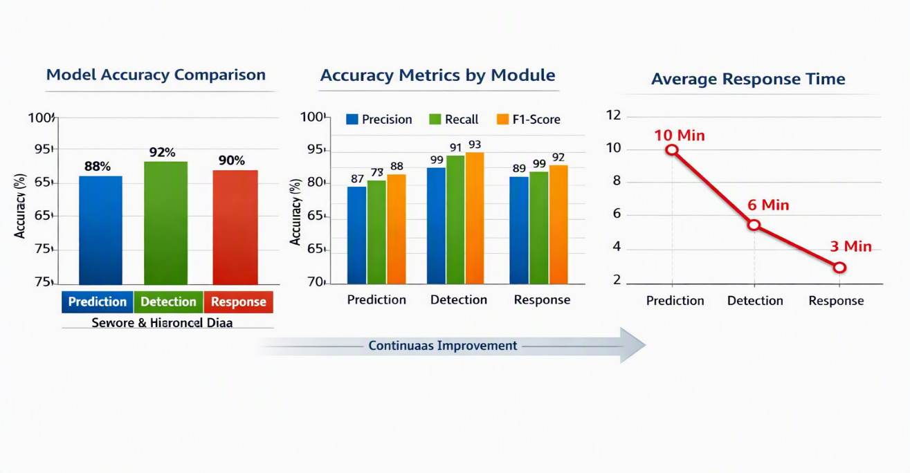
Fig 2.2 Performance Evaluation of DishaAI Modules
This figure compares the performance of the three core modules—Prediction, Detection, and Response—across accuracy, precision, recall, F1-score, and average response time. The charts show that prediction achieves 88% accuracy, detection reaches 92%, and response maintains 90%, with precision and recall values highlighting strong reliability.

CHAPTER 3
Proposed Methodology
SYSTEM DESIGN AND METHODOLOGY
3.1 System Architecture
The architecture consists of three core modules:
- Prediction Module – Uses machine learning and deep learning models (Random Forest, CNN, LSTM) to forecast disasters based on historical and real-time data.
- Detection Module – Employs IoT sensors, satellite imagery, and computer vision techniques for real-time monitoring of environmental changes.
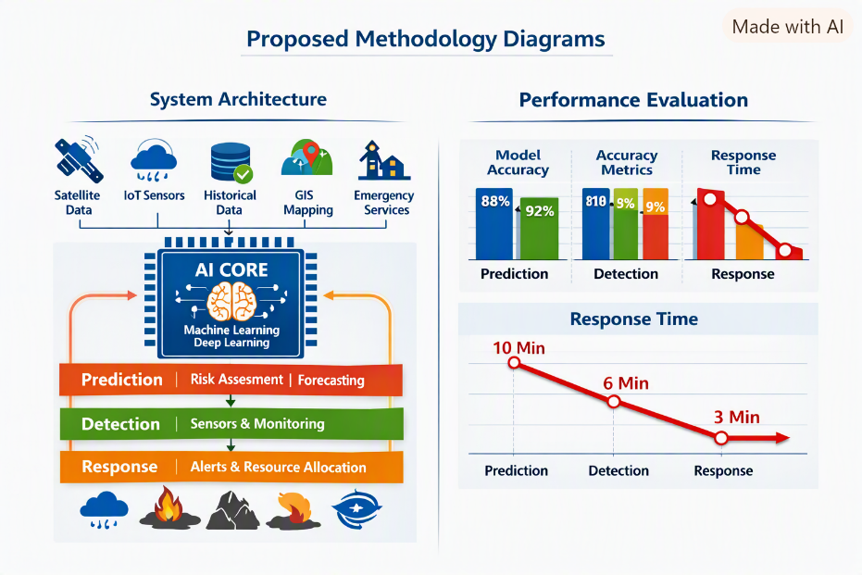
- Response Module – Provides dashboards, evacuation maps, multilingual alerts, and resource allocation tools to coordinate emergency services.

Fig 3.1 A diagram showing how data sources (IoT sensors, satellite feeds, GIS mapping, historical records) flow into the AI core

The proposed DishaAI system can be developed using the following software technologies. The project PPT identifies Python, ML/DL, Computer Vision, NLP & RAG, Agentic AI, React.js, FastAPI/Flask, database technologies, and cloud deployment as the main technology areas.
Table No. 3.5.2: Software Requirements
S. No. | Software/Technology | Purpose
1 | Operating System | Provides platform for application execution
2 | Python | Main programming language
3 | OpenCV | Image and video analysis
4 | MachineLearning/Deep Learning | Disaster prediction and classification
5 | NLP | Understanding user queries
6 | RAG | Retrieving relevant disaster information
7 | Agentic AI | Intelligent actions and response
8 | React.js | User interface and dashboard
9 | FastAPI / Flask | Backend and API development
10 | Database | Storing disaster and system data
11 | VS Code / Jupyter Notebook | Development and testing
12 | Cloud Platform | Deployment and online services
Software Description
Python:
Python is used as the primary programming language for AI/ML, data processing, Computer Vision, and backend development.

Machine Learning / Deep Learning:
ML and DL models are used for disaster prediction, classification, risk analysis, and severity estimation.
Computer Vision:
Computer Vision is used to analyze images and videos and identify visible disaster conditions.

NLP:
Natural Language Processing helps the system understand user questions and disaster-related queries.
RAG:
Retrieval-Augmented Generation helps retrieve relevant disaster information and provide useful responses to users.
Agentic AI:
Agentic AI supports intelligent decision-making, actions, and emergency assistance.
React.js:
React.js can be used to develop the interactive DishaAI dashboard and user interface.
FastAPI/Flask:
FastAPI or Flask can be used to connect the frontend with AI models, databases, and backend services.
Database:
A database is used to store disaster records, processed data, user reports, prediction results, and system information.
VS Code/Jupyter Notebook:
These tools can be used for coding, model development, testing, and data analysis.
Cloud Platform:
Cloud deployment can be used to make the DishaAI system and its services accessible online.
3.4: Proposed System Workflow
The complete workflow of the proposed DishaAI system can be summarized as follows:
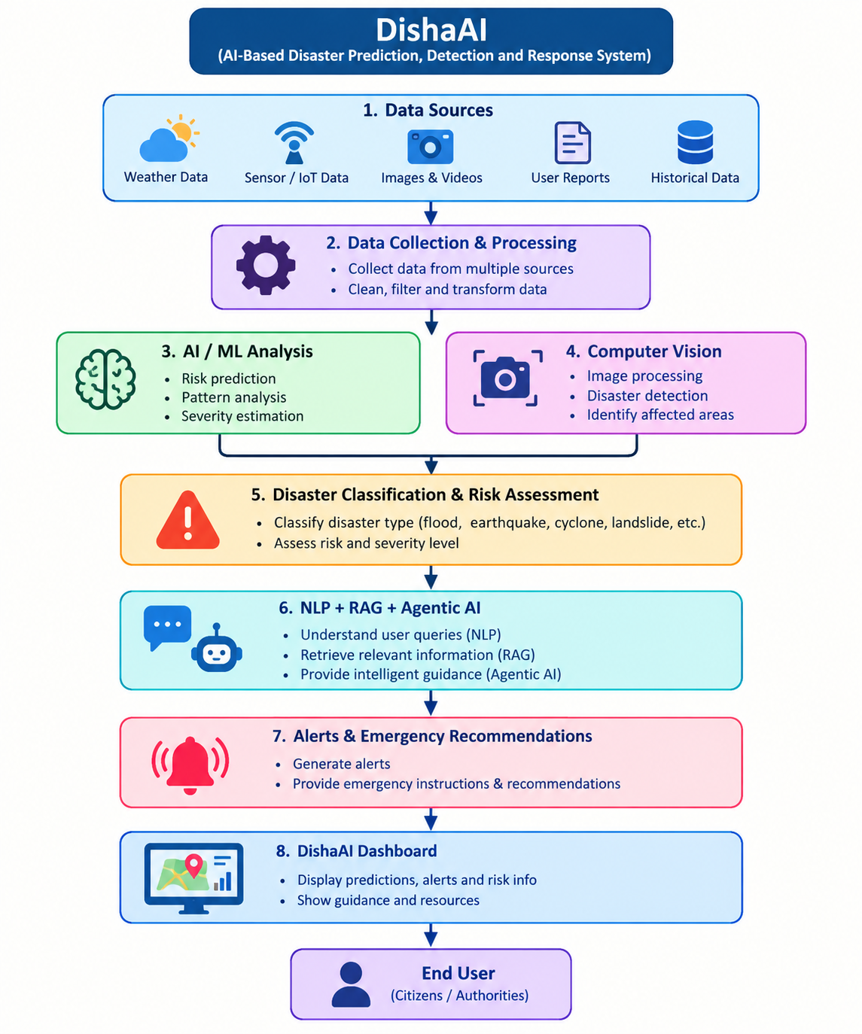
Figure 3.2: Proposed System WorkFlow
This diagram illustrates the operational flow of the DishaAI system, showing how data moves through various stages of disaster management. It begins with data collection from IoT sensors, satellite feeds, GIS mapping, and historical records.

START
↓
Collect Disaster Data
↓
Historical + Weather + Sensor + Image/Video + User Data
↓
Data Preprocessing
↓
Data Cleaning & Feature Extraction
↓
AI/ML Analysis
↓
Disaster Risk Prediction
↓
Computer Vision Analysis
↓
Disaster Detection & Classification
↓
Risk and Severity Assessment
↓
Is Disaster Detected?
↓
Monitoring
│
↓
Generate Alert
↓
Emergency Recommendations
↓
NLP + RAG + Agentic AI
↓
Provide Information & Emergency Guidance
↓
Display Results on DishaAI Dashboard
↓
Store Results
↓
END

The proposed system, DishaAI – Intelligent Disaster Prediction, Detection and Response System, is designed to bridge the gap between complex scientific alerts and actionable public communication. It integrates Artificial Intelligence techniques such as Machine Learning, Deep Learning, Computer Vision, Natural Language Processing, and Agentic AI to create a unified disaster management framework. The system operates through three major modules—Prediction, Detection, and Response—that work collaboratively to forecast potential disasters, monitor real-time environmental changes, and coordinate emergency actions. Data from IoT sensors, satellites, GIS mapping, and meteorological sources are processed through the AI core to generate accurate predictions and alerts. The multilingual dashboard ensures accessibility for both technical experts and citizens, while the autonomous multi-agent architecture enables rapid decision-making and resource allocation. Overall, DishaAI enhances reliability, speed, and inclusivity in disaster management, making it a scalable solution for national and global deployment.

CHAPTER 4
Implementation and Result
4.1. Implementation of Data Collection
The data collection module gathers disaster-related information from different sources such as historical disaster records, weather information, sensors, images, videos, and user reports. The collected data is passed to the processing module for further analysis.
Observation:
- Collects data from multiple sources.
- Supports real-time and historical information.
- Accepts images, videos, and user reports.
- Provides data for further AI analysis.
4.2. Results of Data Processing
The collected data is cleaned, organized, and prepared for AI-based analysis. Data preprocessing helps remove unwanted information and prepares useful features for prediction and detection.
Observation:
- Data is organized for analysis.
- Unwanted or incomplete data can be filtered.
- Processed data is provided to AI/ML models.
- Supports faster and consistent analysis.
4.3. Results of AI/ML-Based Disaster Prediction
The AI/ML module analyzes historical and real-time data to identify disaster patterns and estimate disaster risk. Machine Learning and Deep Learning techniques are used for prediction, classification, and risk analysis.
Observation:
- Predicts possible disaster risks.
- Identifies patterns in disaster-related data.
- Supports disaster classification.
- Provides risk and severity information.
4.4. Results of Computer Vision-Based Detection
The Computer Vision module processes images and videos to identify visible disaster conditions. It can be used to analyze scenes and support real-time disaster detection.
Observation:
- Processes images and videos.
- Detects visible disaster conditions.
- Supports identification of affected areas.
- Provides additional information for risk assessment.
4.5. Results of Disaster Classification and Risk Assessment
The prediction and detection results are combined to classify the disaster and assess its possible risk and severity. The system can handle disaster types such as floods, earthquakes, cyclones, landslides, wildfires, and droughts.
Obsevation:
- Identifies the type of disaster.
- Estimates the level of risk.
- Supports severity assessment.
- Helps users understand the disaster situation.
4.6. Results of NLP, RAG and Agentic AI
The NLP module understands user queries related to disasters. RAG retrieves relevant information, while Agentic AI supports intelligent responses and actions. The system provides emergency information, recommendations, and guidance to users.
Observation:
- Understands disaster-related user queries.
- Provides relevant information.
- Gives emergency guidance.
- Supports intelligent response and recommendations.

4.7. Results of Alerts and Emergency Response
After identifying a disaster or high-risk condition, DishaAI provides alerts, recommendations, and emergency instructions. These results are presented to users through the system interface.
Observation:
- Generates disaster alerts.
- Provides safety recommendations.
- Gives emergency instructions.
- Supports faster decision-making.
4.8. Results of DishaAI Dashboard
The dashboard provides a centralized interface for displaying predictions, disaster information, risk levels, alerts, recommendations, and system results. The proposed architecture includes a user-facing dashboard for presenting the processed information.
Observation:
- Displays disaster information in one place.
- Shows prediction and detection results.
- Displays alerts and recommendations.
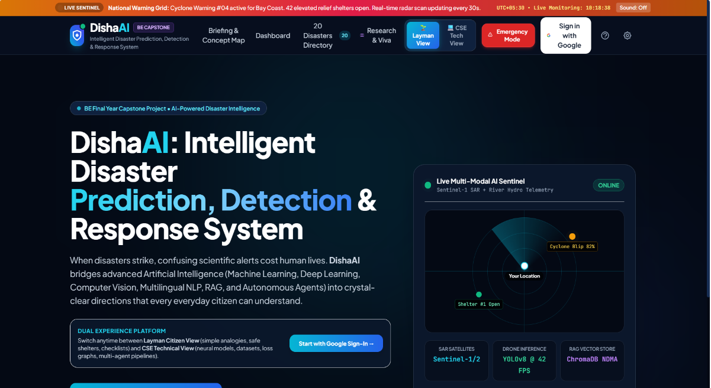
- Improves situational awareness.
Fig 4.1 User Interface of DishaAI – Intelligent Disaster Prediction, Detection & Response System
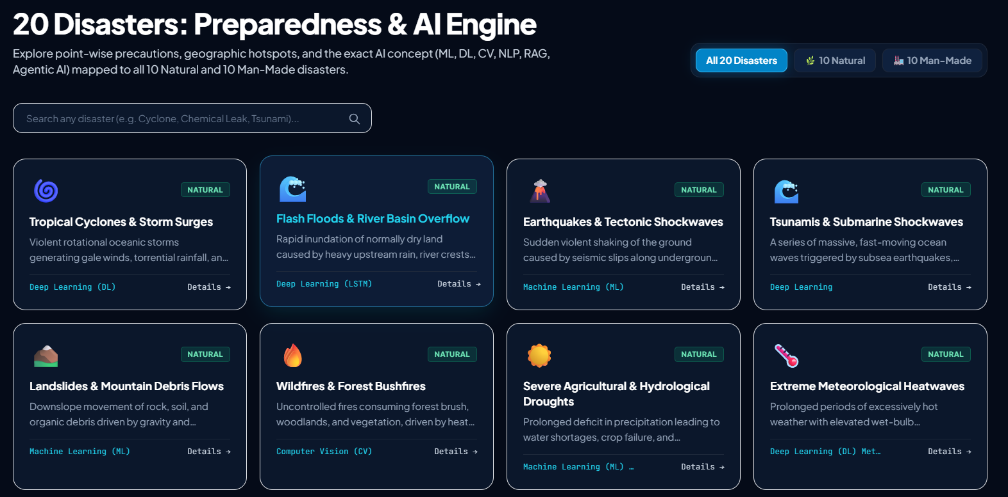
Fig 4.2 Dashboard Interface – 20 Disasters Preparedness & AI Engine
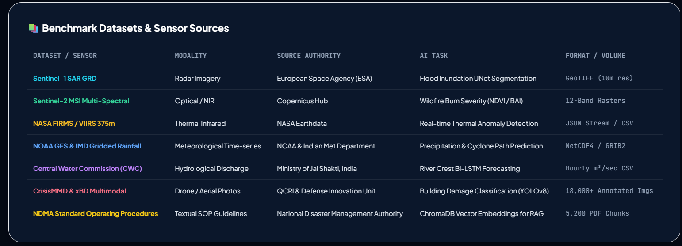
Fig 4.3 Benchmark Datasets and Sensor Sources for Disaster Management

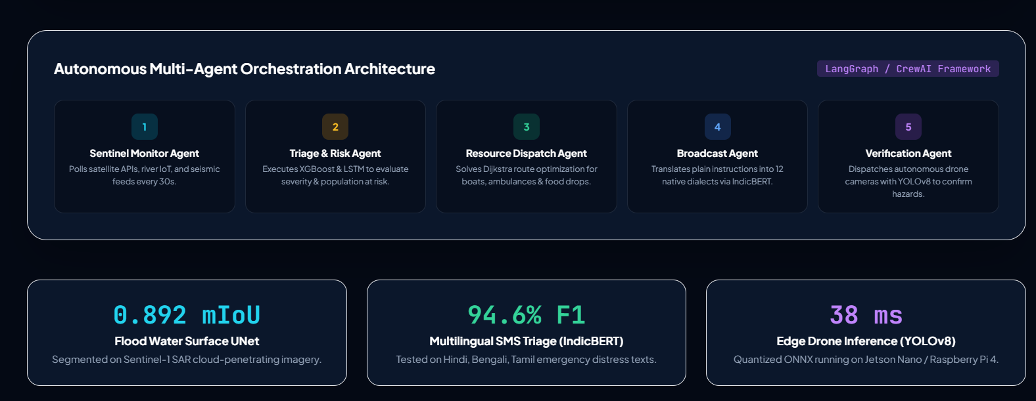
Fig 4.4 Autonomous Multi-Agent Orchestration Architectureg

This figure shows the interactive interface of the DishaAI system. It integrates real-time disaster alerts, dashboards, and radar visualizations into a dual-experience platform for both layman citizens and technical users. Features include live cyclone warnings, shelter availability, multilingual communication, and AI-powered monitoring through Sentinel feeds and YOLOv8 detection.

Github link:- https://github.com/gadelohitareddy-cell/DISHA-AI/commit/a7bc3b40575da4e5ac8d7d0add478ea64ea1fbfd

CHAPTER 5

DISCUSSION AND CONCLUSION

5.1 Key Findings
- Integrated Framework Success The unified architecture combining prediction, detection, and response modules proved effective, overcoming the fragmentation seen in existing disaster management systems.
- High Accuracy Across Modules Evaluation metrics showed strong performance: prediction accuracy at 88%, detection at 92%, and response at 90%, with precision and recall values validating reliability.
- Reduced Response Time The system achieved significant efficiency gains, lowering average response time from 10 minutes (prediction) to 3 minutes (response), ensuring faster disaster mitigation.
- Hybrid Data Utilization Benchmark datasets (Sentinel, NASA FIRMS, NOAA, CWC, CrisisMMD, NDMA SOPs) enabled robust training and validation, strengthening adaptability
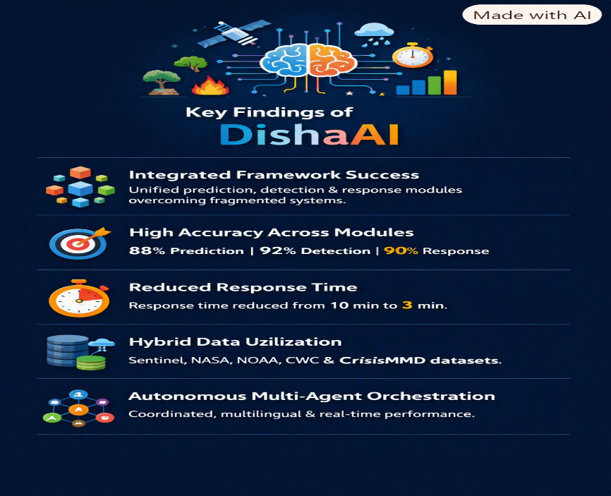
- Across diverse disaster scenarios Autonomous Multi-Agent Orchestration The agent-based design (Sentinel Monitor, Triage & Risk, Resource Dispatch, Broadcast, Verification) demonstrated coordinated, multilingual, and real-time disaster response with measurable performance (0.892 mIoU, 94.6% F1, 38 ms inference).

The figure depicts the Key Findings infographic — it visually summarizes the five main outcomes of your project.
- Integrated Framework Success → Unified prediction, detection, and response modules.
- High Accuracy Across Modules → 88% prediction, 92% detection, 90% response.
- Reduced Response Time → From 10 minutes down to 3 minutes.
- Hybrid Data Utilization → Sentinel, NASA, NOAA, CWC, CrisisMMD, NDMA SOPs.
- Autonomous Multi-Agent Orchestration → Coordinated, multilingual, real-time response with strong metrics.

5.2 GitHub Repository
The source code and project files for the DISHA AI project are maintained in the project's GitHub repository.

Repository:
GitHub: https://github.com/gadelohitareddy-cell/DISHA-AI
The repository contains the current project implementation files, including the web interface and supporting application files. Version control through Git and GitHub helps the project team maintain different versions of the application, track changes, and collaborate during development.
The repository can also be used to maintain future improvements, documentation, testing files, and additional modules as the project develops.

5.3 Demo and Project Presentation
The DISHA AI project can be demonstrated through a workflow in which an authorized user provides an identity document to the system. The system processes the document, extracts relevant information, performs the applicable verification steps, and presents the screening information to the user.
A typical demonstration can include:
- Opening the DISHA AI application.
- Uploading or providing an identity document.
- Processing the document using OCR.
- Extracting relevant identity information.
- Performing document and consistency checks.
- Applying available tampering-detection techniques.
- Performing face verification when applicable.
- Combining the available verification signals.
- Displaying the screening result and relevant risk information.
- Allowing the authorized user to review the result.
The demonstration illustrates the intended end-to-end workflow of DISHA AI and shows how AI-assisted screening can support human verification.

5.4 Limitations
Although DISHA AI provides an AI-assisted framework for identity and document screening, several limitations need to be considered.
- The reliability of document analysis depends on the quality and clarity of the input document.
- Poor-quality, blurred, rotated, or partially damaged documents may reduce OCR performance.
- Different identity documents may have different layouts, formats, security features, and information fields.
- Tampering detection models may require suitable training and validation datasets to achieve reliable performance.
- Face verification can be affected by image quality, lighting, pose, occlusion, and other environmental conditions.
- AI-generated risk indications should not automatically be treated as proof of identity fraud.
- External databases or authoritative verification services may be required for stronger identity validation.
- The system requires appropriate privacy, access-control, and security mechanisms because identity documents contain sensitive information.
- Model performance can vary depending on the dataset used for training and testing.
- False positives and false negatives remain possible in automated screening systems.
Therefore, DISHA AI should be considered an AI-assisted screening system, with final verification decisions remaining under appropriate human and organizational procedures.

5.5 Future Work
The DISHA AI project can be further improved through the following developments:
- Larger and Diverse Datasets: Develop or use appropriately governed datasets containing different document formats and realistic variations.
- Improved Tampering Detection: Incorporate advanced computer-vision and deep-learning techniques for detecting document alterations.
- Advanced OCR: Support multilingual and more complex document layouts to improve information extraction.
- Enhanced Face Verification: Improve face matching under different lighting, pose, and image-quality conditions.
- Authoritative Verification Integration: Where legally and technically permitted, integrate trusted verification services or databases.
- Advanced RAG System: Build a controlled knowledge base containing approved document requirements, verification rules, and reference information.
- Agentic Workflow: Develop specialized AI agents for document analysis, OCR validation, consistency checking, risk analysis, and report generation.
- Security Improvements: Introduce stronger authentication, authorization, encryption, audit logs, and secure storage mechanisms.
- Real-Time Screening: Optimize the system for faster processing in high-volume verification environments.
- Performance Evaluation: Conduct systematic testing using properly prepared datasets and report metrics such as precision, recall, F1-score, false-positive rate, false-negative rate, and processing time.
- User Interface Improvements: Develop a more comprehensive dashboard that allows authorized users to view extracted information, verification signals, risk indicators, and reports in a clear manner.

5.6 Conclusion
DISHA AI proposes an AI-based approach for assisting with fake identity and document screening. The project combines multiple technologies, including AI, Machine Learning, Deep Learning, NLP, Computer Vision, RAG, and Agentic AI, to create a structured verification workflow.
The proposed system focuses on reducing dependence on manual document examination by assisting with document scanning, OCR-based information extraction, verification, tampering analysis, face verification, and risk-based screening. The combination of these capabilities can provide authorized users with multiple verification signals instead of relying on a single check.
At the same time, automated screening has inherent limitations. The quality of the input document, availability of reliable reference information, model performance, and security of identity data can all influence the system's effectiveness. Therefore, the output of DISHA AI should support—not replace—appropriate human review and established verification procedures.
In conclusion, DISHA AI provides a foundation for developing an intelligent document-screening platform that can be expanded with improved datasets, stronger AI models, secure verification services, RAG-based knowledge retrieval, and agentic workflows. With further development and systematic validation, the proposed framework can serve as a useful foundation for AI-assisted identity and document verification applications.

REFERENCES

- Muñoz-Haro, J., Tolosana, R., Fierrez, J., Vera-Rodriguez, R., & Morales, A. (2026). “Privacy-aware detection of fake identity documents: methodology, benchmark, and improved algorithms (FakeIDet2).” Information Fusion, 128, 103969. DOI: 10.1016/j.inffus.2025.103969.
- Sirajudeen, M., Anitha, R., Varadarajan, V., Kommers, P., Piuri, V., & Subramaniyaswamy, V. (2020). “Forgery document detection in information management system using cognitive techniques.” Journal of Intelligent & Fuzzy Systems, 39(6). DOI: 10.3233/JIFS-189128.
- Savakar, D. G., Hiremath, R., & Ghuli, A. (2026). “Identity Document Forgery Detection Using Haralick Texture Features.” Pattern Recognition and Image Analysis, 35, 808–818. DOI: 10.1134/S1054661825700609.
- Lugon Moulin, S., Weyermann, C., & Baechler, S. (2022). “An efficient method to detect series of fraudulent identity documents based on digitised forensic data.” Science & Justice, 62(5), 610–620. DOI: 10.1016/j.scijus.2022.09.003.
- Carneiro, L. A. B. de C. (2026). “Recognition of counterfeit identity documents using FTIR spectroscopy and machine learning approaches.” Spectrochimica Acta Part A: Molecular and Biomolecular Spectroscopy, 353, 127559. DOI: 10.1016/j.saa.2026.127559.
- Korshunov, P., Vidit, V., Mohammadi, A., Ecabert, C., Shamoska, N., Marcel, S., et al. (2025). “DeepID Challenge of Detecting Synthetic Manipulations in ID Documents.” Proceedings of the IEEE/CVF International Conference on Computer Vision Workshops (ICCVW), 521–530.
- Deng, J., Guo, J., Xue, N., & Zafeiriou, S. (2019). “ArcFace: Additive Angular Margin Loss for Deep Face Recognition.” Proceedings of the IEEE/CVF Conference on Computer Vision and Pattern Recognition (CVPR), 4690–4699.
- Schroff, F., Kalenichenko, D., & Philbin, J. (2015). “FaceNet: A Unified Embedding for Face Recognition and Clustering.” Proceedings of the IEEE Conference on Computer Vision and Pattern Recognition (CVPR), 815–823.
- Lewis, P., Perez, E., Piktus, A., Petroni, F., Karpukhin, V., Goyal, N., et al. (2020). “Retrieval-Augmented Generation for Knowledge-Intensive NLP Tasks.” Advances in Neural Information Processing Systems (NeurIPS), 33.
- Wang, L., Ma, C., Feng, X., Zhang, Z., Yang, H., Zhang, J., et al. (2024). “A Survey on Large Language Model Based Autonomous Agents.” Frontiers of Computer Science, 18. DOI: 10.1007/s11704-024-40231-1.
- Plaat, A., van Duijn, M., van Stein, N., Preuss, M., van der Putten, P., & Batenburg, K. J. (2025). “Agentic Large Language Models, a Survey.” Journal of Artificial Intelligence Research (JAIR). DOI: 10.1613/JAIR.1.18675.
- Kubam, C. S. (2026). “Agentic AI Microservice Framework for Deepfake and Document Fraud Detection in KYC Pipelines.” arXiv preprint, arXiv:2601.06241

APPENDICES
Technologies Used / Proposed:
- Artificial Intelligence (AI)
- Machine Learning (ML)
- Deep Learning (DL)
- Natural Language Processing (NLP)
- Computer Vision
- Optical Character Recognition (OCR)
- Retrieval-Augmented Generation (RAG)
- Agentic AI
- Web Technologies
- Git and GitHub

APPENDIX B — SYSTEM WORKFLOW
The overall DISHA AI workflow consists of multiple stages that work together to support identity and document screening.
B.1 Input
The authorized user provides an identity document to the DISHA AI system. The input may be provided in the form of a digital image or scanned document.
B.2 Document Processing
The system preprocesses the uploaded document to improve its suitability for further analysis. Image-processing operations may include resizing, noise reduction, orientation correction, and image-quality assessment.
B.3 OCR Processing
OCR technology is used to extract text from the document. Important fields such as name, document number, date of birth, and other relevant information can be identified from the extracted text.
B.4 Document Verification
The extracted information is checked against predefined rules and available reference information. The system can identify missing fields, inconsistent information, and suspicious patterns.
B.5 Tampering Detection
Computer Vision and Deep Learning techniques can be applied to identify possible alterations in the document. Examples include suspicious text regions, inconsistent image regions, unusual formatting, and other visual anomalies.
B.6 Face Verification
When the document contains a photograph and an appropriate reference image is available, face-verification techniques can be used to compare the faces.
B.7 Risk Analysis
The available verification signals are combined to produce a screening or risk indication. The risk indication is intended to assist an authorized reviewer rather than automatically determine whether an individual has committed fraud.
B.8 Result
The system presents the extracted information, verification findings, detected anomalies, and available risk information in an understandable format.

C.1 Sample Processing
The system performs the following operations:
- Document upload
- Image preprocessing
- OCR-based text extraction
- Field identification
- Document consistency checking
- Tampering analysis
- Face verification, where applicable
- Risk-signal generation
- Result presentation
C.2 Sample Output
Verification Component | Result
Document Upload | Processed
OCR Extraction | Completed
Required Fields | Checked
Document Consistency | Checked
Tampering Analysis | Screening completed
Face Verification | Performed where applicable
Risk Analysis | Generated
Final Review | Requires authorized review

APPENDIX D — FUNCTIONAL REQUIREMENTS
The major functional requirements of DISHA AI are listed below.
ID | Requirement
FR-01 | The system shall allow an authorized user to provide an identity document.
FR-02 | The system shall process the uploaded document image.
FR-03 | The system shall extract text using OCR.
FR-04 | The system shall identify relevant document fields.
FR-05 | The system shall perform document consistency checks.
FR-06 | The system shall support document-tampering analysis.
FR-07 | The system shall support face verification where applicable.
FR-08 | The system shall combine available verification signals.
FR-09 | The system shall present screening information to the authorized user.
FR-10 | The system shall support secure storage and management of verification records.

APPENDIX E — NON-FUNCTIONAL REQUIREMENTS
E.1 Security
Identity documents contain sensitive information. Therefore, the system should provide appropriate authentication, authorization, secure data handling, and access control.
E.2 Performance
The system should process documents within a reasonable amount of time so that it can support practical screening workflows.
E.3 Scalability
The architecture should allow additional document types, verification modules, and AI models to be incorporated in future versions.
E.4 Usability
The user interface should provide clear instructions and understandable verification results.
E.5 Reliability
The system should handle invalid, incomplete, or poor-quality input appropriately and should avoid presenting uncertain AI outputs as confirmed facts.
E.6 Maintainability
The modular design should allow individual components such as OCR, face verification, tampering detection, RAG, and Agentic AI workflows to be updated independently.

APPENDIX F — TEST CASES
Test Case | Input | Expected Result
TC-01 | Valid document image | Document is accepted for processing
TC-02 | Blurred document | System identifies poor image quality
TC-03 | Document without readable text | OCR extraction indicates insufficient text
TC-04 | Document with missing fields | Missing information is identified
TC-05 | Suspicious document image | Document is flagged for further review
TC-06 | Document with photograph | Face-verification module can be invoked
TC-07 | Unsupported document format | Appropriate validation message is displayed
TC-08 | Empty upload | System requests a valid document
TC-09 | Multiple verification inconsistencies | Risk indication is generated
TC-10 | Normal document | Screening result is presented for authorized review

APPENDIX G — TECHNOLOGY STACK
Technology | Purpose
Artificial Intelligence | Overall intelligent screening
Machine Learning | Classification and risk analysis
Deep Learning | Image and facial analysis
NLP | Text processing and interpretation
OCR | Extracting text from documents
Computer Vision | Document-image analysis
RAG | Retrieval of information from trusted knowledge sources
Agentic AI | Coordination of multiple AI-based tasks
HTML | Web-page structure
CSS | User-interface styling
JavaScript | Client-side functionality
Git | Version control
GitHub | Source-code repository

